**Together we aim to:**

“Educate, Inspire and Empower current and future farmers to achieve net zero within a sustainable farming and food system.”

The School of Sustainable Food and Farming at Harper Adams University is supported by our steering partners: Morrisons, McDonalds UK & Ireland and the National Farmers Union.

Our shared purpose is to:

* Equip farmers with skills & knowledge towards Net Zero within sustainability parameters (economic, environmental and social)
* Talk a common language with regards to Net Zero and Sustainable Farming
* Improving farm data to track carbon emission reductions and sequestration offsetting at a whole farm system approach
* Encourage new entrants into the food industry and a diversity of entrepreneurial people

To realise this, we have created 4 delivery pillars.

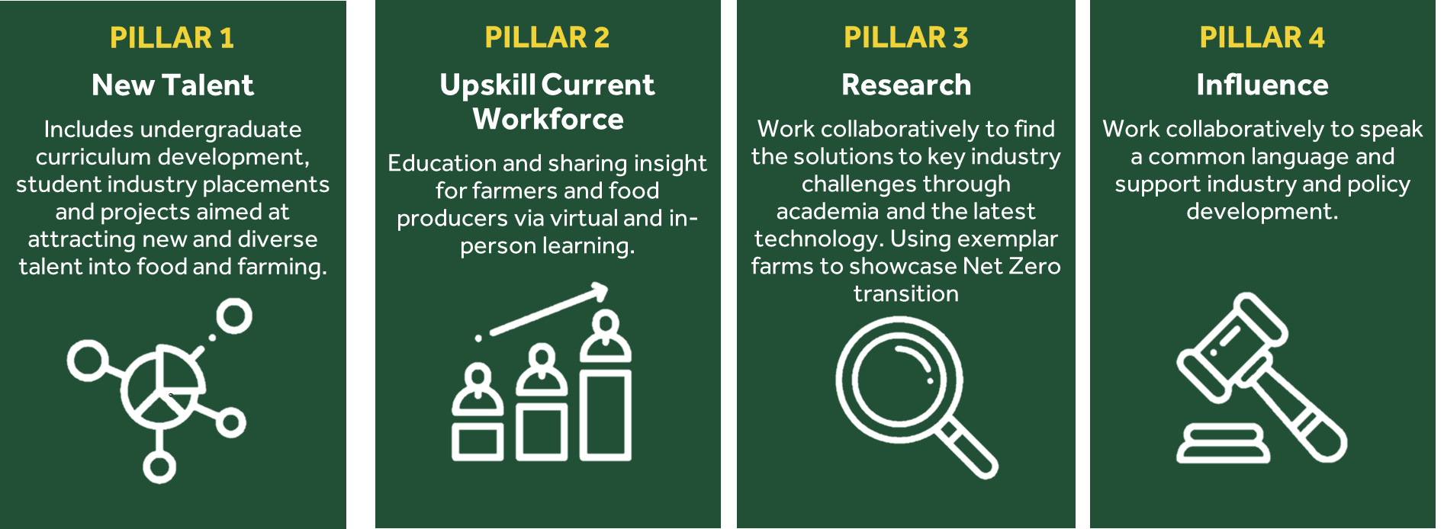

As part of this collaboration, and aligned to pillar 3 research deliverables, funding is available for those at HAU who wish to participate in a small number of research projects to address aspects of sustainability set out in the priority areas below. These projects should also be linked to the work of the ES Farm action groups on: Productivity; Soil & Land; Energy & Water; or Data and System Boundaries. ES Farm action groups are a part of HAU farm strategy, established to be the first farm to achieve Net Zero, within wider sustainability parameters (e.g. biodiversity, economic resilience, animal welfare), and establish a best-practice exemplary mixed farm to support UK agriculture towards sustainable food production which delivers to human, animal and planetary health.

Priority areas for this call are detailed below:

* Valorisation of manures
* Resource efficiency
* Crop nutrients
* Use of data on farms and economics
* Net Zero beef
* Road to Net Zero (all sectors)
* Regenerative agriculture

Examples of types of projects – please be sure to discuss ideas with the ES Farm action groups

* Support for honours research projects (HRPs) individually or in groups lead by an academic with oversight to collate findings.
* Support for staff mini projects.
* Post doc research associate projects.

Size of projects

Projects should be within the size range of £2K - £15K, although larger projects (and smaller) will be considered based on the quality (potential impact) of the submission.

Time scale

Funding is available from **1/9/2022** and projects need to be completed and a short technical report as well as a one-page lay summary prepared by **31/3/2023**.

In addition, timescales for the development of a wider community engagement piece will be agreed individually but must be in a format that is easily accessible, understandable and can be shared through the SSFF website and VLE.

**To apply for this funding please submit the below** (maximum 2 pages; Arial 11-point, 2 cm margins, single space).

1. Project title.
2. Background & underlying rationale, including which ES Farm group (listed below) has been engaged.
3. Specific objectives of the project/activity towards the priority areas
4. Programme and methodology.
5. Detailed costing include a (FEC costing spread sheet from finance if appropriate e.g. employing staff) and justification of resources.
6. Anticipated achievements and outputs with specific timeline.
7. How research outputs would be communicated to the wider community. Examples could be webinar, video or short course.

The applications should be submitted to Prof. Dawn Arnold by **12/7/2022**. A decision will be made within **three** weeks of submission.

For further information please contact Prof. Dawn Arnold [darnold@harper-adams.ac.uk](mailto:darnold@harper-adams.ac.uk)

ES Farm Action groups and contact – please inform these groups of your project ideas so they are aware and can support bids.

1. **Productivity** – **Nicky Naylor** - To define livestock (& arable) improvements to improve efficiency/profitability, reduce emissions and ensure the highest standards of welfare
2. **Land and Soil** – **Julia Casperd** - To define how farm management can improve soil health, improve carbon sequestration and deliver biodiversity
3. **Energy and Water** – **Marie Kirby** - To define how farm management can reduce energy use (including green energy production) and our water footprint
4. **Data and systems boundaries** – **Karl Behrendt** - To organise the collection and inputting of all data into AgreCalc, develop a dashboard to make farm data available to all and define the systems boundaries of the farm Net-Zero